SHEIK AHAMMAD BHASHA

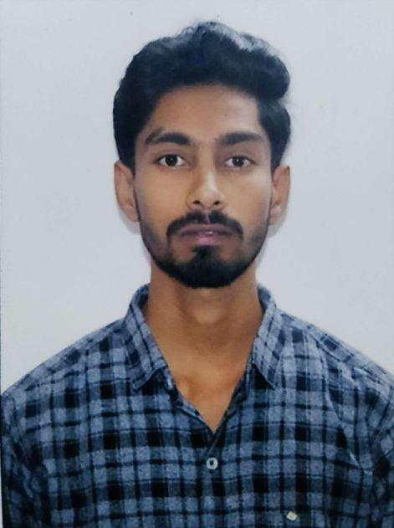

Contact

Address:

D.no-7-160,

Sapta Street,

Vedurupaka,

Rayavaram mandal,

Pincode-533345,

East Godavari,AP.

Phone:
8186016505

Email: sheik-ahammad.bhasha@capgemini.com

Languages

Telugu Hindi English
Urdu

Summary

A self-driven learner eager to work in a team of dedicated people and serve a key role in the enhancement and development of the project.
Ready to learn new Technologies and implement them to further improve my knowledge.
Back-End Technologies

- Core Java
- Spring Boot
- Spring MVC

Front-End Technologies

- HTML
- CSS
- Java Script
- Angular

Education

Bachelor of Technology: Mechanical Engineering 2016-19,
Aditya College of Engineering , Surampalem.

Additional Details

- Quick learner
- Leadership
- Team management

